|  |
| --- |
| **BHARATI VIDYAPEETH (DEEMED TO BE UNIVERSITY)** |
| **COLLEGE OF ENGINEERING** |
| **DEPARTMENT OF ENGINEERING & TECHNOLOGY OFFCAMPUS, KHARGHAR, NAVI MUMBAI,410210** |



Mini Project Report

**On**

**Hotel Management Website**

**Subject-: -** Internet Programming

***Presented By***

|  |  |  |
| --- | --- | --- |
| **Roll No.** | **Name** | **PRN** |
| 41 | Siddhant Sinha | 2343110098 |
| 42 | Srijan Sundaram | 2343110291 |
| 46 | Vardaan Prakash | 2343110093 |
| 49 | Jithesh Shetty | 2343110084 |

## Signature of Internal Examiner

|  |
| --- |
| **BHARATI VIDYAPEETH (DEEMED TO BE UNIVERSITY)** |
| **COLLEGE OF ENGINEERING** |
| **DEPARTMENT OF ENGINEERING & TECHNOLOGY OFFCAMPUS, KHARGHAR, NAVI MUMBAI,410210** |



This is to certify that the project entitled, “Hotel Management Website”, which is being submitted here with for the award of B.Tech. AIML Department, is the result of the work completed by Siddhant Sinha under my supervision and guidance within the four walls of the institute and the same has not been submitted elsewhere for the award of any degree.

**Submitted By:**

Siddhant Sinha,

Srijan Sundaram,

Vardaan Prakash,

Jithesh Shetty

## Guide (Head of Department)

DEPARTMENT OF ENGINEERING & DEPARTMENT OF ENGINEERING &

TECHNOLOGY OFFCAMPUS, TECHNOLOGY OFFCAMPUS

KHARGHAR, NAVI MUMBAI KHARGHAR, NAVI MUMBAI

## Principal

DEPARTMENT OF ENGINEERING & TECHNOLOGY OFFCAMPUS, KHARGHAR, NAVI MUMBAI

# Abstract

The project, Hotel Management System is a web-based application that allows the hotel manager to handle all hotel activities online. Interactive GUI and the ability to manage various hotel bookings and rooms make this system very flexible and convenient. The hotel manager is a very busy person and does not have the time to sit and manage the entire activities manually on paper. This application gives him the power and flexibility to manage the entire system from a single online system. Hotel management project provides room booking, staff management and other necessary hotel management features. The system allows the manager to post available rooms in the system. Customers can view and book room online. Admin has the power of either approving or disapproving the customer’s booking request. Other hotel services can also be viewed by the customers and can book them too. The system is hence useful for both customers and managers to portable manage the hotel activities.

# Index

|  |  |  |
| --- | --- | --- |
| Chapter No. | Title | Page No. |
| 1 | The Motive | 5 |
| 2 | Introduction to Project | 7 |
| 3 | Hotel Services | 9 |
| 4 | Codes | 12 |
| 5 | Result | 63 |
| 6 | Conclusion | 74 |
|  | References | 76 |

**THE MOTIVE**

The motive of our project is to control various activities performed. In the Hotel using the computer with the work of HOTEL MANGEMENT SYSTEM. From the beginning, the important thing in our mind is that we should concentrate our project work on a subject that is easy to understand and is according to our daily requirement. By keeping this in mind, the subject chosen by us is hotel management.

In the present time there is a great rush in hotels, as these have become necessity for middle and upper class of the society. People travel a lot, stay in hotels, goes to the hotels for functions, meeting and refreshment. Our project is developed keeping in mind the general needs of the customers when he goes to the hospital. An important uniqueness about the described Hotel’s restaurants and bar are available to only those customers who have already booked room or hall in hospital.

**INTRODUCTION TO PROJECT**

The name of project is “Hotel Management”. The objective of the project is to computerize the system of the hotel. “Hotel Management” is the project not only keeps the record of various people like customers, manager etc. but as well as it reduce the extensive paper work in the present system. It wills maker the system more versatile and user friendly. It also calculates the proper billing slip of high level and middle level customers. This project is based on description about the structure of HOTEL MANAGEMENT SYSTEM.

The project contains:

* Keeping the record of all persons like customers, managers etc.
* Maintains proper list of all persons.

**HOTEL SERVICES**

The present-day modern concept of the hotel is not just a place to provide `accommodation, food and beverage, but like city within a city and offering the every possible facilities, accommodation, service and convenience, not such as rooms.

There are more facilities like- cosmetic things, hairdryer, cock tail lounges, radio and TV etc. There is a professionally qualified, highly trained, experienced, and efficient. Courteous staff in smart, clean uniforms and the staff coming in the contact.

With guests could understand English. There is a 24hrs service for reception, information and telephone. There is a plentiful supply of linen, blanket, towels and so on. Each bedroom is provided with good vacuum jug/ thermos flask with ice cold, boiled drinking water.

Further additional services such as given below:

* Fruits, flowers
* Clubs
* Bank services
* Swimming pool
* Theatre
* Hospital
* Library
* Service station
* Post office
* Poultry farms
* Car rental and chauffeurs
* Cinema ticket

**Chapter 3.1**

**Facilities**

* There is a reception, cash and information counter attended by highly qualified, trained and experienced personnel conference facilities in the form of one each or more of the conference rooms.
* There is a book stall, recognized travel agency, money change and safe deposit facilities, etc.
* There is a telephone in each room and telephone for the use of guests and visitors and provision for a radio or relayed music in each room.
* There is a well-equipped, well-furnished and well-maintained dining room/restaurant on the premises and wherever permissible by law, there is an elegant, well-equipped bar /permit room.
* There is dancing facility and orchestra in dining hall.



**Chapter 3.2**

**Departments in our Hotel**

* PERSONNEL
* SALES
* LAUNDRY
* HOUSEKEEPING
* MAINTAINENCE
* CREDIT
* COMPUTER CENTRE
* SECURITY
* PURCHASE AND RECEIVING
* MAIN STORES
* ACCOUNTS
* HEALTH CLUB
* PRODUCTION
  + MAIN KITCHEN
  + SATELLITE KITCHEN
  + BAKERY
* FOOD AND BEVERAGE SERVICES
  + RESTAURENTS
  + BANQUETS
  + COFFEE SHOP
  + ROOM SERVICE
  + BARS

**CODES**

**Chapter 4.1**

**CSS**

**Chapter 4.1.1**

**STYLESHEET**

/* Style */

html,body,div,span,applet,object,iframe,h1,h2,h3,h4,h5,h6,p,blockquote,pre,a,abbr,acronym,address,big,cite,code,del,dfn,em,img,ins,kbd,q,s,samp,small,strike,strong,sub,sup,tt,var,b,u,i,dl,dt,dd,ol,nav ul,nav li,fieldset,form,label,legend,table,caption,tbody,tfoot,thead,tr,th,td,article,aside,canvas,details,embed,figure,figcaption,footer,header,hgroup,menu,nav,output,ruby,section,summary,time,mark,audio,video{margin:0;padding:0;border:0;font-size:100%;font:inherit;vertical-align:baseline;}

article, aside, details, figcaption, figure,footer, header, hgroup, menu, nav, section {display: block;}

ol,ul{list-style:none;margin:0px;padding:0px;}

blockquote,q{quotes:none;}

blockquote:before,blockquote:after,q:before,q:after{content:'';content:none;}

table{border-collapse:collapse;border-spacing:0;}

/* start editing from here */

a{text-decoration:none;}

.txt-rt{text-align:right;}/* text align right */

.txt-lt{text-align:left;}/* text align left */

.txt-center{text-align:center;}/* text align center */

.float-rt{float:right;}/* float right */

.float-lt{float:left;}/* float left */

.clear{clear:both;}/* clear float */

.pos-relative{position:relative;}/* Position Relative */

.pos-absolute{position:absolute;}/* Position Absolute */

.vertical-base{ vertical-align:baseline;}/* vertical align baseline */

.vertical-top{  vertical-align:top;}/* vertical align top */

nav.vertical ul li{ display:block;}/* vertical menu */

nav.horizontal ul li{   display: inline-block;}/* horizontal menu */

img{max-width:100%;}

body{

    background: url(../images/box-bg.png);

}

/*end reset*/

/*=============================

 * start-wrap

 ============================*/

.wrap{

    width:98%;

    margin:0 auto;

}

/*=============================

 * start-header

 ============================*/

.header{

    background: url(../images/box1.png) repeat-x;

}

.header-top{

    padding: 41px 0 30px 0;

}

.logo{

    float:left;

    margin-top: 0.8em;

}

.contact-info{

    float:right;

}

.contact-info p{

    font-family: 'PT Sans Narrow', sans-serif;

    font-size: 1.3em;

    font-weight: 400;

    color: #3B3B3B;

    text-transform: uppercase;

}

.header-top-nav ul li{

    display: inline-block;

    border-left: 1px solid rgba(85, 85, 85, 0.41);

    float: left;

}

.header-top-nav ul li a{

    color: #FFF;

    font-family: 'PT Sans Narrow', sans-serif;

    font-size: 1.3em;

    font-weight: 400;

    text-transform: uppercase;

    display: block;

    padding: 11px 35px;

}

.header-top-nav li.active> a, .header-top-nav li> a:hover {

    color: #ff9900;

    background: #454545;

}

.header-top-nav{

    background: url(../images/top-nav-bg.png) repeat-x;

}

.phone:before{

    content: url(../images/phone.png);

    vertical-align: middle;

    padding: 0px 5px 0px 0px;

}

.gpa:before{

    content:url(../images/pointer.png);

    vertical-align: middle;

    padding: 0px 5px 0px 0px;

}

/*=============================

 * start-content

 ============================*/

.content-grid-pic{

    float:left;

    width:25%;

    margin-top: 27px;

}

.content-grid-pic img{

    display: block;

    border-radius: 50%;

    border: 5px solid #fff;

    box-shadow: 0px 0px 10px rgba(119, 119, 119, 0.25)

}

.content-grid-info{

    float:right;

    width: 69.5%;

}

.content-grid-info h3{

    font-family: 'PT Sans Narrow', sans-serif;

    font-size: 1.8em;

    font-weight: 400;

    color: #995c00;

    text-transform: uppercase;

}

.content-grid-info p{

    font-family: Arial, Helvetica, sans-serif;

    color: #6a6a6a;

    font-size: 0.875em;

    padding: 5px 0 5px 0;

    line-height: 1.5em;

}

.content-grid{

    float:left;

    width:33.333%;

}

.content-grids{

    padding: 3.5em 0 3.7em 0;

    background: url(../images/box.png);

    margin:0 0 40px 0px;

}

.start:before{

    content: url(../images/quote-1.png);

    vertical-align: super;

    padding-right:5px;

}

.end:after{

    content: url(../images/quote-2.png);

    vertical-align: super;

    padding-right:5px;

}

.quit p{

    font-family: 'PT Sans Narrow', sans-serif;

    font-size: 2em;

    font-weight: 400;

    color: #3B3B3B;

    text-transform: uppercase;

    display: block;

    width: 60%;

    text-align: center;

    margin: 0.5em auto;

}

/*=============================

 * start-content-box

 ============================*/

.content-box-left{

    float:left;

    width:70%;

}

.content-box-left-topgrid h3{

    font-family: 'PT Sans Narrow', sans-serif;

    font-size: 1.8em;

    font-weight: 400;

    color: #995c00;

    text-transform: uppercase;

    border-bottom: 1px solid rgba(85, 85, 85, 0.1);

    padding: 0em 0 0.2em 0;

    margin: 0px 0px 0.5em 0;

}

.content-box-left-topgrid p{

    font-family: Arial, Helvetica, sans-serif;

    color: #6a6a6a;

    font-size: 0.875em;

    padding: 5px 0 5px 0;

    line-height: 1.5em;

}

.content-box-left-topgrid span{

    font-family: 'PT Sans Narrow', sans-serif;

    font-size: 1.8em;

    font-weight: 400;

    color: #3B3B3B;

    text-transform: uppercase;

    border-top: 1px solid rgba(85, 85, 85, 0.1);

    border-bottom: 1px solid rgba(85, 85, 85, 0.1);

    padding: 1em 0;

    display: block;

    width: 100%;

    text-align: center;

    margin: 0.5em 0;

}

.content-box-left-bootomgrid{

    width:31.33%;

    float:left;

    margin-right:3%;

}

.content-box-left-bootomgrid h3{

    font-family: 'PT Sans Narrow', sans-serif;

    font-size: 1.3em;

    font-weight: 400;

    color: #3B3B3B;

    text-transform: uppercase;

}

.content-box-left-bootomgrid p{

    font-family: Arial, Helvetica, sans-serif;

    color: #6a6a6a;

    font-size: 0.875em;

    padding: 0.5em 0;

    line-height: 1.8em;

}

.content-box-left-bootomgrid img{

    background:#FFF;

    padding:5px;

    display:block;

    width: 93%;

    transition: 0.5s ease;

    -o-transition: 0.5s ease;

    -webkit-transition: 0.5s ease;

}

.content-box-left-bootomgrids {

    padding: 0.5em 0 2em 0;

}

.lastgrid{

    margin:0;

}

/*-----boxs-----*/

.boxs {

    background: url(../images/box.png);

    padding: 1.5em 0 1em 0;

    margin: 40px 0px 0 0;

}

.box{

    width: 29.33%;

    float: left;

}

.center-box{

    border-right: 1px dashed silver;

    border-left: 1px dashed silver;

    padding: 0px 40px;

    margin-right: 40px;

}

.center-box ul li{

    display: block;

    padding: 0px 0px 10px 0px;

}

.center-box ul li a{

    font-family: 'PT Sans Narrow', sans-serif;

    font-size: 18px;

    line-height: 22px;

    text-transform: uppercase;

    color: #454545;

    font-family: 'PT Sans Narrow', sans-serif;

}

.center-box ul li:before{

    content:url(../images/marker.png);

    padding: 10px;

}

.center-box ul{

    margin-top:30px;

}

/*---start-copy-tight-----*/

.copy-tight{

    text-align: center;

    padding: 0px 0px 0.6em 0;

}

.copy-tight p{

    font-family: 'PT Sans Narrow', sans-serif;

    font-size: 1.3em;

    font-weight: 400;

    color: #3B3B3B;

    text-transform: uppercase;

}

/*---start-about----*/

/*----start-about-----*/

.about-grid{

    width: 31.33%;

    float: left;

}

.about-grid h3{

    font-family: 'PT Sans Narrow', sans-serif;

    font-size: 30px;

    font-weight: 400;

    line-height: 2em;

    margin: 0;

    text-transform: uppercase;

    color: #454545;

}

.about-grid span{

    font-family: Arial, Helvetica, sans-serif;

    color: #6a6a6a;

    font-size: 0.875em;

    padding: 5px 0 1px 0;

    line-height: 1.5em;

    font-weight: bold;

    display: block;

}

.about-grid p{

    font-family: Arial, Helvetica, sans-serif;

    color: #6a6a6a;

    font-size: 0.875em;

    padding: 5px 0 10px 0;

    line-height: 1.8em;

}

.center-grid1 p{

    padding:0px 0px 10px 0px;

}

.center-grid1 label{

    font-family: 'PT Sans Narrow', sans-serif;

    font-size: 18px;

    line-height: 22px;

    text-transform: uppercase;

    color: #71D6EA;

    font-family: 'PT Sans Narrow', sans-serif;

    cursor:pointer;

}

.center-grid1{

    margin:0 3%;

}

.about-team-left{

    float:left;

    width:25%;

}

.about-team-right{

    float:right;

    width: 73%;

}

.about-team-right p{

    font-family:    sans-serif;

    color: #6a6a6a;

    font-size: 0.875em;

    padding: 0px 0 10px 0;

    line-height: 1.8em;

}

.client {

    padding-bottom: 10px;

}

.about-grids {

    padding: 10px 0px 0px 0px;

}

.about-team-left img {

    -webkit-filter: grayscale(100%);

    opacity: 5;

    transition: all 300ms!important;

    -webkit-transition: all 300ms!important;

    -moz-transition: all 300ms!important;

}

.about-team-left img:hover {

    opacity: 1;

    -webkit-filter: grayscale(0%);

    cursor: pointer;

}

/*---services----*/

.service-content h3{

    font-family: 'PT Sans Narrow', sans-serif;

    font-size: 30px;

    font-weight: 400;

    line-height: 2em;

    margin: 0;

    text-transform: uppercase;

    color: #454545;

}

.service-content ul li{

    display: block;

}

.service-content ul li span{

    width: 5%;

    float: left;

    font-size: 3em;

    color: #454545;

    font-family: 'PT Sans Narrow', sans-serif;

}

.service-content ul li p{

    font-family: Arial, Helvetica, sans-serif;

    color: #6a6a6a;

    font-size: 0.875em;

    padding: 5px 0 10px 0;

    line-height: 1.8em;

}

.service-content ul li p a{

    font-size: 1.5em;

    color: #454545;

    font-family: 'PT Sans Narrow', sans-serif;

    display: block;

}

.service-content{

    float:left;

    width: 74.5%;

}

.service-content ul{

    padding-bottom:5px;

}

.services-sidebar{

    float:right;

    width:23%;

}

.services-sidebar h3{

    font-family: 'PT Sans Narrow', sans-serif;

    font-size: 30px;

    font-weight: 400;

    line-height: 2em;

    margin: 0;

    text-transform: uppercase;

    color: #454545;

}

.services-sidebar ul li a{

    display: block;

    font-family: 'PT Sans Narrow', sans-serif;

    font-size: 1em;

    color: #454545;

    padding: 2px 0px 5px 0px;

    transition: 0.5s ease;

    -o-transition: 0.5s ease;

    -webkit-transition: 0.5s ease;

}

.services-sidebar ul li a:hover{

    color: #71D6EA;

}

.services-sidebar ul li {

    border-bottom: 1px dashed rgba(192, 192, 192, 0.33);

    background: url(../images/marker.png) 0 15px no-repeat;

    padding: 9px 13px 8px 23px;

}

.services {

    padding-top: 10px;

}

/*---contact----*/

/*  Contact Form*/

.col{

    display: block;

    float:left;

    margin: 1% 0 1% 1.6%;

}

.col:first-child{

    margin-left:0;

}

.span_2_of_3 {

    width: 63.1%;

    padding:1.5%;

}

.span_1_of_3 {

    padding:1.5%;

}

.span_2_of_3  h3,

.span_1_of_3  h3 {

    font-family: 'PT Sans Narrow', sans-serif;

    font-size: 30px;

    font-weight: 400;

    line-height: 2em;

    margin: 0;

    text-transform: uppercase;

    color: #454545;

}

.contact-form div{

    padding:5px 0;

}

.contact-form span{

    display:block;

    font-size:1em;

    color: #454545;

    padding-bottom:5px;

    font-family: 'PT Sans Narrow', sans-serif;

}

.contact-form input[type="text"],.contact-form textarea{

            padding:8px;

            display:block;

            width:98%;

            border: none;

            outline:none;

            color:#464646;

            font-size:0.8125em;

            font-family:Arial, Helvetica, sans-serif;

            border: 1px solid rgba(192, 192, 192, 0.41);

            -webkit-appearance:none;

}

.contact-form textarea{

        resize:none;

        height:120px;

}

.contact-form input[type="submit"]{

    font-family: 'PT Sans Narrow', sans-serif;

    font-size: 20px;

    font-weight: 400;

    line-height: 1.2em;

    text-decoration: none;

    text-transform: uppercase;

    margin-right: 15px;

    text-align: center;

    margin: 0 auto;

    color: #71D6EA;

    border:none;

    outline: none;

    background:none;

    cursor:pointer;

}

.company_address{

}

.company_address p{

    font-size: 0.875em;

    color: #6a6a6a;

    line-height: 1.8em;

    font-family: Arial, Helvetica, sans-serif;

}

.FAQs details{

    font-size: 1em;

    color: #b36b00;

    line-height: 2em;

    font-family: Arial, Helvetica, sans-serif;

}

main {

    max-width: 400px;

    margin: 2rem auto;

    padding: 0.4rem;

    border-radius: 5px;

    font-size: 1.2em;

    color: #6a6a6a

}

.booking-form {

    text-align: center;

}

form {

    display: block;

    text-align: left;

}

.form-group {

    margin: 1rem 0;

}

label {

    font-size: 1.2em;

    color: #6a6a6a

    display: block;

}

input[type="date"],

input[type="number"],

input[type="text"] {

    width: 90%;

    padding: 0.5rem;

    border: 1px solid #ccc;

    border-radius: 3px;

    font-size: 1em;

    color: #6a6a6a

}

**Chapter 4.1.2**

**GALLERY**

* {

    margin: 0;

    padding: 0;

}

.img-gallery {

    width: 80%;

    margin: 100px auto 50px;

    display: grid;

    grid-template-columns: repeat(auto-fit, minmax(250px, 1fr));

    grid-gap: 30px;

}

.img-gallery img{

    width: 100%;

    cursor: pointer;

}

.full-img {

    width: 100%;

    height: 100vh;

    background: rgba(0, 0, 0, 0.9);

    position: fixed;

    top: 0;

    left: 0;

    display: none;

    align-items: center;

    justify-content: center;

    z-index: 100;

}

.full-img img{

    width: 90%;

    max-width: 500px;

}

.full-img span{

    position: absolute;

    top: 5%;

    right: 5%;

    font-size: 30px;

    color: white;

    cursor: pointer;

}

**Chapter 4.1.3**

**RESPONSIVE SLIDES**

* {box-sizing: border-box;}

        .slideshow-container {

            max-width: 1600px;

            position: relative;

            margin: auto;

        }

        .mySlides {

            display: none;

            width: 100%;

            padding: 0.5px 0;

            text-align: center;

        }

        .mySlides img {

            width: 100%;

            height: auto;

        }

        .prev, .next {

            cursor: pointer;

            position: absolute;

            top: 10%;

            width: auto;

            margin-top: -22px;

            padding: 16px;

            color: white;

            font-weight: bold;

            font-size: 18px;

            transition: 0.6s ease;

            border-radius: 0 3px 3px 0;

            user-select: none;

        }

        .next {

            right: 0;

            border-radius: 3px 0 0 3px;

        }

        .prev:hover, .next:hover {

            background-color: rgba(0,0,0,0.8);

        }

**Chapter 4.3**

**MAIN**

**Chapter 4.3.1**

**HOME**

<!DOCTYPE HTML>

<html>

<head>

<title>Getaway Mansion | Home</title>

<link href="css/style.css" rel="stylesheet" type="text/css" media="all" />

<link href='https://fonts.googleapis.com/css?family=Raleway ' rel='stylesheet' type='text/css'>

<link rel="stylesheet" href="css/responsiveslides.css">

</head>

<body>

<!---start-Wrap--->

<!---start-header--->

<div class="header">

<div class="wrap">

<div class="header-top">

<div class="logo">

<a href="index.html"><img src="images/logo2.png" title="logo" /></a>

</div>

<div class="contact-info">

<p class="phone">Call us : (061) 518972</a></p>

<p class="gpa">GPS : <a href="https://www.google.com/maps/place/SAI+MANNAT/@19.0714617,73.0845242,16.18z/data=!4m6!3m5!1s0x3be7c1fb5b9ea011:0xc3067d98b973f1d5!8m2!3d19.0708176!4d73.0824813!16s%2Fg%2F11cm0vyjfm?entry=ttu">View map</a></p>

<p class="code">BROUGHT TO YOU BY: BOOLEAN AUTOCRATS</a></p>

</div>

<div class="clear"> </div>

</div>

</div>

<div class="header-top-nav">

<div class="wrap">

<ul>

<li class="active"><a href="index.html">Home</a></li>

<li><a href="services.html">Services</a></li>

<li><a href="gallery.html">Gallery</a></li>

<li><a href="contact.html">Contact</a></li>

<li><a href="about.html">About us</a></li>

<li><a href="booking.html">Book Now</a></li>

<div class="clear"> </div>

</ul>

</div>

</div>

</div>

<!---End-header--->

<div class="clear"> </div>

<!--start-image-slider---->

<div class="slideshow-container">

<div class="mySlides fade">

<img src="images/slider1.jpg" style="width:100%">

</div>

<div class="mySlides fade">

<img src="images/slider2.jpeg" style="width:100%">

</div>

<div class="mySlides fade">

<img src="images/slider3.jpg" style="width:100%">

</div>

<div class="mySlides fade">

<img src="images/slider4.jpg" style="width:100%">

</div>

<div class="mySlides fade">

<img src="images/slider5.jpg" style="width:100%">

</div>

<div class="mySlides fade">

<img src="images/slider6.jpg" style="width:100%">

</div>

<a class="prev" onclick="plusSlides(-1)">&#10094;</a>

<a class="next" onclick="plusSlides(1)">&#10095;</a>

</div>

<script>

var slideIndex = 0;

showSlides();

function showSlides() {

var i;

var slides = document.getElementsByClassName("mySlides");

for (i = 0; i < slides.length; i++) {

slides[i].style.display = "none";

}

slideIndex++;

if (slideIndex > slides.length) {slideIndex = 1}

slides[slideIndex-1].style.display = "block";

setTimeout(showSlides, 3000); // Change image every 3 seconds

}

function plusSlides(n) {

showSlides(slideIndex += n);

}

</script>

<!--End-image-slider---->

<!---start-content----->

<div class="content">

<div class="quit">

<p><span class="start">One step close to Paradise</span><span class="end"></span></p>

</div>

<div class="content-grids">

<div class="wrap">

<div class="content-grid">

<div class="content-grid-pic">

<img src="images/icon1.png" title="image-name" />

</div>

<div class="content-grid-info">

<h3>Best food Ever</h3>

<p>"One cannot think well, love well, sleep well, if one has not dined well."</p>

</div>

<div class="clear"> </div>

</div>

<div class="content-grid">

<div class="content-grid-pic">

<img src="images/icon2.png" title="image-name" />

</div>

<div class="content-grid-info">

<h3>24x7 phone support</h3>

<p>"Instead of focusing on the competition, focus on the customer."</p>

</div>

<div class="clear"> </div>

</div>

<div class="content-grid">

<div class="content-grid-pic">

<img src="images/iocn3.png" title="image-name" />

</div>

<div class="content-grid-info">

<h3>Best Room Services</h3>

<p>"Relaxation at a beautiful peak."</p>

</div>

<div class="clear"> </div>

</div>

<div class="clear"> </div>

</div>

</div>

<div class="clear"> </div>

<div class="content-box">

<div class="wrap">

<div class="content-box-centre">

<div class="content-box-left-topgrid">

<h3>welcome to our Hotel</h3>

<p> ' Feel Like Home :)</p>

<p> Our hotel is located in multiple cities with great location, close to business centres and tourist attractions, our hotels will meet your expectations. Chill-out and bar area available for you to relax. Coffee and tea facilities in all rooms, Wi-Fi, fitness and Privilege lounge. Meals and drinks available 24/7.</p>

<span>Where class meets comfort</span>

</div>

<div class="content-box-left-bootomgrids">

<div class="content-box-left-bootomgrid">

<h3>Standard Rooms</h3>

<p>Standard rooms, are modern decorated that can accommodate up to 2 persons, totally soundproofed and equipped with high tech comforts such as high speed internet access, USB ports , smart TV and room cleaning touch system.</p>

<img src="images/slider4.jpg" title="Standard Rooms" />

</div>

<div class="content-box-left-bootomgrid">

<h3>Deluxe Rooms</h3>

<p>Deluxe rooms, are modern decorated, can accommodate up to 2 persons, totally soundproofed and equipped with high tech comforts such as high speed internet access, USB ports , smart TV, room cleaning touch system and private hydromassage bathtub.</p>

<img src="images/slider5.jpg" title="Deluxe Rooms" />

</div>

<div class="content-box-left-bootomgrid lastgrid">

<h3>Executive Rooms</h3>

<p>These aesthetically designed suites boast of a luxurious living room, an inviting bedroom with a predominant Indian theme and a bathroom with twin massage showers. Each of these suites come equipped with business-friendly workstations and facilities to cater to all your needs.</p>

<img src="images/slider6.jpg" title="Executive Rooms" />

</div>

<div class="clear"> </div>

</div>

<div class="clear"> </div>

</div>

</div>

</div>

</div>

</div>

<div class="clear"> </div>

<div class="boxs">

<div class="wrap">

<div class="box">

</div>

<div class="box center-box">

<ul>

<li><a href="https://www.trivago.in/">Leave us Feedback</a></li>

<li><a href="https://www.trivago.in/">Reviews and Ratings</a></li>

<li><a href="faqs.html">FAQs</a></li>

</ul>

</div>

<div class="clear"> </div>

</div>

<!---start-box---->

</div>

<!---start-copy-Right----->

<div class="copy-tight">

<p>&copy Getaway Mansion,Kharghar 2023 "THIS PROJECT IS BROUGHT TO YOU BY BOOLEAN AUTOCRATS"</a></p>

</div>

<!---End-copy-Right----->

</div>

<!---End-content----->

</div>

<!---End-Wrap--->

</body>

</html>

**Chapter 4.3.2**

**SERVICES**

<html>

<head>

<title>Hotel Website | Services</title>

<link href="css/style.css" rel="stylesheet" type="text/css"  media="all" />

<link href='http://fonts.googleapis.com/css?family=PT+Sans+Narrow' rel='stylesheet' type='text/css'>

</head>

<body>

<!---start-Wrap--->

<!---start-header--->

<div class="header">

<div class="wrap">

<div class="header-top">

<div class="logo">

<a href="index.html"><img src="images/logo2.png" title="logo" /></a>

</div>

<div class="contact-info">

<p class="phone">Call us : (061) 518972</a></p>

<p class="gpa">Gpa : <a href="https://www.google.com/maps/place/SAI+MANNAT/@19.0714617,73.0845242,16.18z/data=!4m6!3m5!1s0x3be7c1fb5b9ea011:0xc3067d98b973f1d5!8m2!3d19.0708176!4d73.0824813!16s%2Fg%2F11cm0vyjfm?entry=ttu">View map</a></p>

<p class="code">BROUGHT TO YOU BY: BOOLEAN AUTOCRATS</a></p>

</div>

<div class="clear"> </div>

</div>

</div>

<div class="header-top-nav">

<div class="wrap">

<ul>

<li><a href="index.html">Home</a></li>

<li class="active"><a href="services.html">Services</a></li>

<li><a href="gallery.html">Gallery</a></li>

<li><a href="contact.html">Contact</a></li>

<li><a href="about.html">About us</a></li>

<li><a href="booking.html">Book Now</a></li>

<div class="clear"> </div>

</ul>

</div>

</div>

</div>

<!---End-header--->

<div class="clear"> </div>

<!---start-content----->

<div class="content">

<div class="wrap">

<!-----start--services------>

<div class="services">

<div class="service-content">

<h3>Our Hotel Services</h3>

<ul>

<li><span>1.</span></li>

<li><p><a>RESTAURANT</a>Our Michelin star restaurant, with a world class gourmet trained staff is truly the place where mind and soul coalesce into one true elegant experience...</p></li>

<br><br><center><img src="images/rest.jpg" alt="restaurant" height="500", width="900"></center><br><br>

<div class="clear"> </div>

</ul>

<ul>

<li><span>2.</span></li>

<li><p><a>SWIMMING POOL</a> Bliss of the purest kind awaits you in our temperature-controlled infinity swimming pool, topped off with a beautiful sceneic view of the city...</p></li>

<br><br><center><img src="images/pool.jpg" alt="pool" height="500", width="900"></center><br><br>

<div class="clear"> </div>

</ul>

<ul>

<li><span>3.</span></li>

<li><p><a>GARDEN</a> Right in the midst of nature, our beautiful garden is perfect for relaxing walks, shrouded with local flora for the natural experience...</p></li>

<br><br><center><img src="images/garden.jpg" alt="garden" height="500", width="900"></center><br><br>

<div class="clear"> </div>

</ul>

<ul>

<li><span>4.</span></li>

<li><p><a>CONFERENCE HALL</a>For the workaholics, a state of the art conference room with cutting edge requirements for a fruitful and productive work experience...</p></li>

<br><br><center><img src="images/conf.jpg" alt="conference hall" height="500", width="900"></center><br><br>

<div class="clear"> </div>

</ul>

<ul>

<li><span>5.</span></li>

<li><p><a>SPA</a>Experience true class and luxury with our world class masseurs, state of the art equipment, and calming music...</p></li>

<br><br><center><img src="images/spa.jpg" alt="spa" height="500", width="900"></center><br><br>

<div class="clear"> </div>

</ul>

</div>

<div class="services-sidebar">

<h3>PROVISIONS...</h3>

<ul>

<li><a href="https://www.cntraveler.com/gallery/india-top-hotels"><h1>We're listed in the top 20 hotels in India</h1></a></li>

<li><a href="https://www.medicoverhospitals.in/hospitals/maharashtra/">On call quality healthcare available 24/7</a></li>

<li><a href="https://www.thomascook.in/">Excursions arranged daily</a></li>

<li><a href="https://www.uber.com/in/en/ride/">Taxi service available</a></li>

</ul>

</div>

<div class="clear"> </div>

</div>

<!-----End--services------>

</div>

<div class="clear"> </div>

<div class="boxs">

<div class="wrap">

<div class="box">

</div>

<div class="box center-box">

<ul>

<li><a href="https://www.trivago.in/">Leave us Feedback</a></li>

<li><a href="https://www.trivago.in/">Reviews and Ratings</a></li>

<li><a href="faqs.html">FAQs</a></li>

</ul>

</div>

<div class="clear"> </div>

</div>

<!---start-box---->

</div>

<!---start-copy-Right----->

<div class="copy-tight">

<p>&copy Getaway Mansion,Kharghar 2023 "THIS PROJECT IS BROUGHT TO YOU BY BOOLEAN AUTOCRATS"</a></p>

</div>

<!---End-copy-Right----->

</div>

<!---End-content----->

</div>

<!---End-Wrap--->

</body>

</html>

**Chapter 4.3.3**

**GALLERY**

<!DOCTYPE html>

<html lang="en">

<head>

<meta charset="UTF-8">

<title>Getaway Mansion | Gallery</title>

<link href="css/style.css" rel="stylesheet" type="text/css"  media="all" />

<link href='https://fonts.googleapis.com/css?family=Raleway ' rel='stylesheet' type='text/css'>

<link rel="stylesheet" href="css/gallery.css">

</head>

<body>

<!---start-Wrap--->

<!---start-header--->

<div class="header">

<div class="wrap">

<div class="header-top">

<div class="logo">

<a href="index.html"><img src="images/logo2.png" title="logo" /></a>

</div>

<div class="contact-info">

<p class="phone">Call us : (061) 518972</a></p>

<p class="gpa">Gpa : <a href="https://www.google.com/maps/place/SAI+MANNAT/@19.0714617,73.0845242,16.18z/data=!4m6!3m5!1s0x3be7c1fb5b9ea011:0xc3067d98b973f1d5!8m2!3d19.0708176!4d73.0824813!16s%2Fg%2F11cm0vyjfm?entry=ttu">View map</a></p>

<p class="code">BROUGHT TO YOU BY: BOOLEAN AUTOCRATS</a></p>

</div>

<div class="clear"> </div>

</div>

</div>

<div class="header-top-nav">

<div class="wrap">

<ul>

<li><a href="index.html">Home</a></li>

<li><a href="services.html">Services</a></li>

<li class="active"><a href="gallery.html">Gallery</a></li>

<li><a href="contact.html">Contact</a></li>

<li><a href="about.html">About us</a></li>

<li><a href="booking.html">Book Now</a></li>

<div class="clear"> </div>

</ul>

</div>

</div>

</div>

<!---End-header--->

<div class="clear"> </div>

<br>

<div class="full-img" id="fullImgBox">

<img src="images/img1.jpg" id="fullImg">

<span onclick="closeFullImg()">X</span>

</div>

<div class="img-gallery">

<img src="images/img1.jpg" onclick="openFullImg(this.src)">

<img src="images/img2.jpg" onclick="openFullImg(this.src)">

<img src="images/img3.jpg" onclick="openFullImg(this.src)">

<img src="images/img4.jpg" onclick="openFullImg(this.src)">

<img src="images/img5.jpg" onclick="openFullImg(this.src)">

<img src="images/img6.jpg" onclick="openFullImg(this.src)">

<img src="images/img7.jpg" onclick="openFullImg(this.src)">

<img src="images/img8.jpg"onclick="openFullImg(this.src)" >

</div>

<script>

var fullImgBox = document.getElementById("fullImgBox");

var fullImg = document.getElementById("fullImg");

function  openFullImg(pic) {

fullImgBox.style.display = "flex";

fullImg.src = pic;

}

function closeFullImg() {

fullImgBox.style.display = "none";

}

</script>

</div>

<div class="clear"> </div>

<div class="boxs">

<div class="wrap">

<div class="box">

</div>

<div class="box center-box">

<ul>

<li><a href="https://www.trivago.in/">Leave us Feedback</a></li>

<li><a href="https://www.trivago.in/">Reviews and Ratings</a></li>

<li><a href="faqs.html">FAQs</a></li>

</ul>

</div>

<div class="clear"> </div>

</div>

<!---start-box---->

</div>

<!---start-copy-Right----->

<div class="copy-tight">

<p>&copy Getaway Mansion,Kharghar 2023 "THIS PROJECT IS BROUGHT TO YOU BY BOOLEAN AUTOCRATS"</a></p>

</div>

<!---End-copy-Right----->

</div>

<!---End-content----->

</div>

<!---End-Wrap--->

</body>

</html>

**Chapter 4.3.4**

**CONTACT**

<!DOCTYPE HTML>

<html>

<head>

<title> Getaway Mansion | Contact</title>

<link href="css/style.css" rel="stylesheet" type="text/css"  media="all" />

<link href='http://fonts.googleapis.com/css?family=PT+Sans+Narrow' rel='stylesheet' type='text/css'>

<script>

function myfunction() {

alert("Your response has been recorded. We will reach you shortly.");

}

</script>

</head>

<body>

<!---start-Wrap--->

<!---start-header--->

<div class="header">

<div class="wrap">

<div class="header-top">

<div class="logo">

<a href="index.html"><img src="images/logo2.png" title="logo" /></a>

</div>

<div class="contact-info">

<p class="phone">Call us : (061) 518972</a></p>

<p class="gpa">Gpa : <a href="https://www.google.com/maps/place/SAI+MANNAT/@19.0714617,73.0845242,16.18z/data=!4m6!3m5!1s0x3be7c1fb5b9ea011:0xc3067d98b973f1d5!8m2!3d19.0708176!4d73.0824813!16s%2Fg%2F11cm0vyjfm?entry=ttu">View map</a></p>

<p class="code">BROUGHT TO YOU BY: BOOLEAN AUTOCRATS</a></p>

</div>

<div class="clear"> </div>

</div>

</div>

<div class="header-top-nav">

<div class="wrap">

<ul>

<li><a href="index.html">Home</a></li>

<li><a href="services.html">Services</a></li>

<li><a href="gallery.html">Gallery</a></li>

<li class="active"><a href="contact.html">Contact</a></li>

<li><a href="about.html">About us</a></li>

<li><a href="booking.html">Book Now</a></li>

<div class="clear"> </div>

</ul>

</div>

</div>

</div>

<!---End-header--->

<div class="clear"> </div>

<!-------start-contatct------>

<div class="contact">

<div class="section group">

<div class="col span_1_of_3">

<div class="contact_info">

</div>

<div class="company_address">

<h3>Reach us at :</h3>

<p>Address,</p>

<p>Getaway Mansion,</p>

<p>Plot No. 1, Sector 34 A, Navi Mumbai, Kharghar, Maharashtra 410210</p>

<p>Phone:(061) 518972</p>

<p>Email: <span>info@getawaymansion.com</span></p>

<p>Follow us on: <span>Facebook</span>, <span>Twitter</span></p>

<p><b>THIS PROJECT IS BROUGHT TO YOU BY BOOLEAN-AUTOCRATS</b></p>

</div>

</div>

<div class="col span_2_of_3">

<div class="contact-form">

<h3>Contact Us</h3>

<form>

<div>

<span><label>FULL NAME</label></span>

<span><input name="userName" type="text" class="textbox"></span>

</div>

<div>

<span><label>E-MAIL ID</label></span>

<span><input name="userEmail" type="text" class="textbox"></span>

</div>

<div>

<span><label>MOBILE NUMBER</label></span>

<span><input name="userPhone" type="text" class="textbox"></span>

</div>

<div>

<span><label>SUBJECT</label></span>

<span><textarea name="userMsg"> </textarea></span>

</div>

<div>

<span><input type="submit" onclick="myfunction()" value="Submit"></span>

</div>

</form>

</div>

</div>

</div>

</div>

<!-------start-contatct------>

</div>

<div class="clear"> </div>

<div class="boxs">

<div class="wrap">

<div class="box">

</div>

<div class="box center-box">

<ul>

<li><a href="https://www.trivago.in/">Leave us Feedback</a></li>

<li><a href="https://www.trivago.in/">Reviews and Ratings</a></li>

<li><a href="faqs.html">FAQs</a></li>

</ul>

</div>

<div class="clear"> </div>

</div>

<!---start-box---->

</div>

<!---start-copy-Right----->

<div class="copy-tight">

<p>&copy Getaway Mansion,Kharghar 2023 "THIS PROJECT IS BROUGHT TO YOU BY BOOLEAN AUTOCRATS"</a></p>

</div>

<!---End-copy-Right----->

</div>

<!---End-content----->

</div>

<!---End-Wrap--->

</body>

</html>

**Chapter 4.3.5**

**ABOUT US**

<!DOCTYPE HTML>

<html>

<head>

<title> Hotel Website | About</title>

<link href="css/style.css" rel="stylesheet" type="text/css"  media="all" />

<link href='http://fonts.googleapis.com/css?family=PT+Sans+Narrow' rel='stylesheet' type='text/css'>

</head>

<body>

<!---start-Wrap--->

<!---start-header--->

<div class="header">

<div class="wrap">

<div class="header-top">

<div class="logo">

<a href="index.html"><img src="images/logo2.png" title="logo" /></a>

</div>

<div class="contact-info">

<p class="phone">Call us : (061) 518972</a></p>

<p class="gpa">Gpa : <a href="https://www.google.com/maps/place/SAI+MANNAT/@19.0714617,73.0845242,16.18z/data=!4m6!3m5!1s0x3be7c1fb5b9ea011:0xc3067d98b973f1d5!8m2!3d19.0708176!4d73.0824813!16s%2Fg%2F11cm0vyjfm?entry=ttu">View map</a></p>

<p class="code">BROUGHT TO YOU BY: BOOLEAN AUTOCRATS</a></p>

</div>

<div class="clear"> </div>

</div>

</div>

<div class="header-top-nav">

<div class="wrap">

<ul>

<li><a href="index.html">Home</a></li>

<li><a href="services.html">Services</a></li>

<li><a href="gallery.html">Gallery</a></li>

<li><a href="contact.html">Contact</a></li>

<li class="active"><a href="about.html">About us</a></li>

<li><a href="booking.html">Book Now</a></li>

<div class="clear"> </div>

</ul>

</div>

</div>

</div>

<!---End-header--->

<div class="clear"> </div>

<!---start-content----->

<div class="content">

<div class="wrap">

<!---start-about---->

<div class="about">

<div class="about-grids">

<div class="about-grid">

<h3>About Our Hotel</h3>

<br><br><img src="images/slider1.jpg" title="about"></a>

<br><br><br><br><span>  Welcome to Getaway Mansion, a luxurious escape nestled in the heart of paradise. Our enchanting hotel offers a harmonious blend of opulence and tranquility, providing guests with an unparalleled retreat from the hustle and bustle of everyday life. With its majestic architecture, lush gardens, and impeccable service, Getaway Mansion promises an unforgettable experience, where relaxation, rejuvenation, and indulgence seamlessly converge. Whether you're seeking a romantic getaway, a family vacation, or a corporate retreat, our exquisite accommodations and world-class amenities ensure that every moment spent at Getaway Mansion is a cherished memory. Discover the epitome of hospitality in an idyllic setting, where every stay is a journey into elegance and serenity.</span>

</div>

<div class="about-grid center-grid1">

<h3>WHY CHOOSE US?</h3>

<p>Choose Getaway Mansion for a splendid retreat that harmonizes luxury, serenity, and attentive service.<br><br> With its captivating design, lush gardens, and unwavering dedication to your comfort, our hotel promises an extraordinary escape from the ordinary.<br><br> Whether you seek family bonding or a corporate sanctuary, our lavish accommodations and top-tier amenities ensure that every stay is an indelible masterpiece.<br><br> At Getaway Mansion, we redefine the art of hospitality, making your choice an exceptional one.</p>

<br><br><br><br><br><br><br><br>

<div style="text-align: right;"><label> Follow us on our socials</label></div>

</div>

<div class="about-grid last-grid">

<h3>Our Team's Info.</h3>

<div class="about-team">

<div class="client">

<div class="about-team-left">

<a href="#"><img src="images/c11.jpg" title="Srijan Sundaram"></a>

</div>

<div class="about-team-right">

<p> Srijan Sundaram</p>

</div>

<div class="clear"> </div>

</div>

<div class="client">

<div class="about-team-left">

<a href="#"><img src="images/c12.jpg" title="Siddhant Sinha"></a>

</div>

<div class="about-team-right">

<p>Siddhant Sinha</p>

</div>

<div class="clear"> </div>

</div>

<div class="client">

<div class="about-team-left">

<a href="#"><img src="images/c13.jpg" title="Jithesh Shetty"></a>

</div>

<div class="about-team-right">

<p>Jithesh Shetty</p>

</div>

<div class="clear"> </div>

</div>

<div class="client">

<div class="about-team-left">

<a href="#"><img src="images/c14.jpg" title="Vardaan Prakash"></a>

</div>

<div class="about-team-right">

<p>Vardaan Prakash</p>

</div>

<div class="clear"> </div>

</div>

</div>

</div>

<div class="clear"> </div>

</div>

</div>

</div>

<!---End-about---->

<div class="clear"> </div>

<div class="boxs">

<div class="wrap">

<div class="box">

</div>

<div class="box center-box">

<ul>

<li><a href="https://www.trivago.in/">Leave us Feedback</a></li>

<li><a href="https://www.trivago.in/">Reviews and Ratings</a></li>

<li><a href="faqs.html">FAQs</a></li>

</ul>

</div>

<div class="clear"> </div>

</div>

<!---start-box---->

</div>

<!---start-copy-Right----->

<div class="copy-tight">

<p>&copy Getaway Mansion,Kharghar 2023 "THIS PROJECT IS BROUGHT TO YOU BY BOOLEAN AUTOCRATS"</a></p>

</div>

<!---End-copy-Right----->

</div>

<!---End-content----->

</div>

<!---End-Wrap--->

</body>

</html>

**Chapter 4.3.6**

**BOOK NOW**

<!DOCTYPE HTML>

<html>

<head>

<title>Getaway Mansion | Book Now </title>

<!-- <link href="css/booking.css" rel="stylesheet" type="text/css"  media="all" /> -->

<link href="css/style.css" rel="stylesheet" type="text/css" media="all" />

<link href='http://fonts.googleapis.com/css?family=PT+Sans+Narrow' rel='stylesheet' type='text/css'>

<script>

function myfunction() {

alert("Your booking has been confirmed. Pay at the time of Check-In");

}

</script>

</head>

<body>

<!---start-Wrap--->

<!---start-header--->

<div class="header">

<div class="wrap">

<div class="header-top">

<div class="logo">

<a href="index.html"><img src="images/logo2.png" title="logo" /></a>

</div>

<div class="contact-info">

<p class="phone">Call us : (061) 518972</a></p>

<p class="gpa">Gpa : <a href="https://www.google.com/maps/place/SAI+MANNAT/@19.0714617,73.0845242,16.18z/data=!4m6!3m5!1s0x3be7c1fb5b9ea011:0xc3067d98b973f1d5!8m2!3d19.0708176!4d73.0824813!16s%2Fg%2F11cm0vyjfm?entry=ttu">View map</a></p>

<p class="code">BROUGHT TO YOU BY: BOOLEAN AUTOCRATS</a></p>                            </div>

<div class="clear"> </div>

</div>

</div>

<div class="header-top-nav">

<div class="wrap">

<ul>

<li><a href="index.html">Home</a></li>

<li><a href="services.html">Services</a></li>

<li><a href="gallery.html">Gallery</a></li>

<li><a href="contact.html">Contact</a></li>

<li><a href="about.html">About us</a></li>

<li class="active"><a href="booking.html">Book Now</a></li>

<div class="clear"> </div>

</ul>

</div>

</div>

</div>

<!---End-header--->

<div class="clear"> </div>

<!---start-content----->

<div class="content">

<div class="wrap">

<!-------start-Booking Page------>

<main>

<section class="booking-form">

<h2>Reservation Details</h2>

<form>

<div class="form-group">

<label for="Your Name">Your Name:</label>

<input type="text" id="name" name="name" required>

<label for="check-in-Rooms">Select your Room:</label>

<!-- <input type="text" id="name" name="name" required> -->

<select name="rooms" id="rooms">

<option value="Standard">Standard</option>

<option value="Executive">Executive</option>

<option value="Deluxe">Deluxe</option>

</select>

</div>

<div class="form-group">

<label for="check-in-date">Check-in Date:</label>

<input type="date" id="check-in-date" name="check-in-date" required>

</div>

<div class="form-group">

<label for="check-out-date">Check-out Date:</label>

<input type="date" id="check-out-date" name="check-out-date" required>

</div>

<div class="form-group">

<label for="guests">Number of Adults:</label>

<input type="number" id="guests" name="guests" required>

</div>

<div class="form-group">

<label for="guests">Number of Kids:</label>

<input type="number" id="guests" name="guests" required>

</div>

<div class="form-group">

<button type="submit" onclick="myfunction()">Book</button>

</div>

</div>

</form>

</section>

</main>

<!-------start-Booking------>

</div>

</div>

<div class="clear"> </div>

<div class="boxs">

<div class="wrap">

<div class="box">

</div>

<div class="box center-box">

<ul>

<li><a href="https://www.trivago.in/">Leave us Feedback</a></li>

<li><a href="https://www.trivago.in/">Reviews and Ratings</a></li>

<li><a href="faqs.html">FAQs</a></li>

</ul>

</div>

<div class="clear"> </div>

</div>

<!---start-box---->

</div>

<!---start-copy-Right----->

<div class="copy-tight">

<p>&copy Getaway Mansion,Kharghar 2023 "THIS PROJECT IS BROUGHT TO YOU BY BOOLEAN AUTOCRATS"</a></p>

</div>

<!---End-copy-Right----->

</div>

<!---End-content----->

</div>

<!---End-Wrap--->

</body>

**Chapter 4.3.7**

**FAQs**

<!DOCTYPE HTML>

<html>

<head>

<title>Getaway Mansion | FAQs </title>

<link href="css/style.css" rel="stylesheet" type="text/css"  media="all" />

<link href='http://fonts.googleapis.com/css?family=PT+Sans+Narrow' rel='stylesheet' type='text/css'>

</head>

<body>

<!---start-Wrap--->

<!---start-header--->

<div class="header">

<div class="wrap">

<div class="header-top">

<div class="logo">

<a href="index.html"><img src="images/logo2.png" title="logo" /></a>

</div>

<div class="contact-info">

<p class="phone">Call us : (061) 518972</a></p>

<p class="gpa">Gpa : <a href="https://www.google.com/maps/place/SAI+MANNAT/@19.0714617,73.0845242,16.18z/data=!4m6!3m5!1s0x3be7c1fb5b9ea011:0xc3067d98b973f1d5!8m2!3d19.0708176!4d73.0824813!16s%2Fg%2F11cm0vyjfm?entry=ttu">View map</a></p>

<p class="code">BROUGHT TO YOU BY: BOOLEAN AUTOCRATS</a></p>

</div>

<div class="clear"> </div>

</div>

</div>

<div class="header-top-nav">

<div class="wrap">

<ul>

<li class="active"><a href="index.html">Home</a></li>

<li><a href="services.html">Services</a></li>

<li><a href="gallery.html">Gallery</a></li>

<li><a href="contact.html">Contact</a></li>

<li><a href="about.html">About us</a></li>

<li><a href="booking.html">Book Now</a></li>

<div class="clear"> </div>

</ul>

</div>

</div>

</div>

<!---End-header--->

<div class="clear"> </div>

<!---start-content----->

<div class="content">

<div class="wrap">

<!-------start-FAQs------>

<div class="FAQs">

<div class="section group">

<div class="col span_1_of_3">

<div class="FAQs">

</div>

<div class="FAQs">

<h3>FAQs :</h3>

<details>

<summary>How do I request an early check-in or late check-out with the hotel?</summary>

<div style="color: black;">

Since hotel policies regarding early check-in (generally before 2:00 pm) or late checkout (generally after 12:00 pm) vary by location and by hotel, please call the hotel directly prior to your arrival to make any necessary arrangements. Direct hotel phone numbers can be found on your confirmation email or on the hotel information page.

</div>

</details>

<details>

<summary>What is your policy regarding cancellation?</summary>

<divstyle="color: black;">

If your travel plans change, you can cancel or modify your reservation in accordance with the hotel's cancellation policy as stated during the reservation process.

</div>

</details>

<details>

<summary>Will i be charged for extra guests occupying my room?</summary>

<div style="color: black;">

Hotel room rates vary by date and by the number of adults occupying a single room. To accommodate more guests, you need to change your reservation. You will be notified of any additional charges prior to confirming your updated reservation.

</div>

</details>

<details>

<summary>Is there a minimum age requirement to reserve a hotel room?</summary>

<div style="color: black;">

Although individual hotel policies may vary, most hotels have a minimum age requirement of 21 years old. Please call the hotel directly prior to your arrival to make any necessary arrangements. Direct hotel phone numbers can be found in your confirmation email or on the respective hotel information page.

</div>

</details>

<details>

<summary>Can Getaway Mansion supply a cot or crib for my room when I travel with children?</summary>

<div style="color: black;">

We'll do everything possible to accommodate your request. Please note all special requests in the “Add comment” area when making a reservation on our website.

</div>

</details>

<details>

<summary>Who can I call if I want to speak to someone when visiting a Getaway Mansion Group brand website?</summary>

<div style="color: black;">

For any queries regarding brand content, please get in touch with the appropriate regional office.

</div>

</details>

<details>

<summary>Can I reserve more than one room at a time when I book online?</summary>

<div style="color: black;">

Yes, you can book up to nine rooms at a time. Please see the list of toll-free numbers to contact in your country if you wish to order ten or more rooms.

</div>

</details>

<details>

<summary>Can I cancel or change reservation once it has been made?</summary>

<div style="color: black;">

Yes. If your travel plans change, you can cancel or modify your reservation in accordance with the Radisson Hotel Group cancellation policy as stated during the reservation process.

</div>

</details>

</div>

</div>

</div>

</div>

<!-------start-FAQs------>

</div>

<div class="clear"> </div>

<div class="boxs">

<div class="wrap">

<div class="box">

</div>

<div class="box center-box">

<ul>

<li><a href="https://www.trivago.in/">Leave us Feedback</a></li>

<li><a href="https://www.trivago.in/">Reviews and Ratings</a></li>

<li><a href="faqs.html">FAQs</a></li>

</ul>

</div>

<div class="clear"> </div>

</div>

<!---start-box---->

</div>

<!---start-copy-Right----->

<div class="copy-tight">

<p>&copy Getaway Mansion,Kharghar 2023 "THIS PROJECT IS BROUGHT TO YOU BY BOOLEAN AUTOCRATS"</a></p>

</div>

<!---End-copy-Right----->

</div>

<!---End-content----->

</div>

<!---End-Wrap--->

</body>

</html>

**Result**

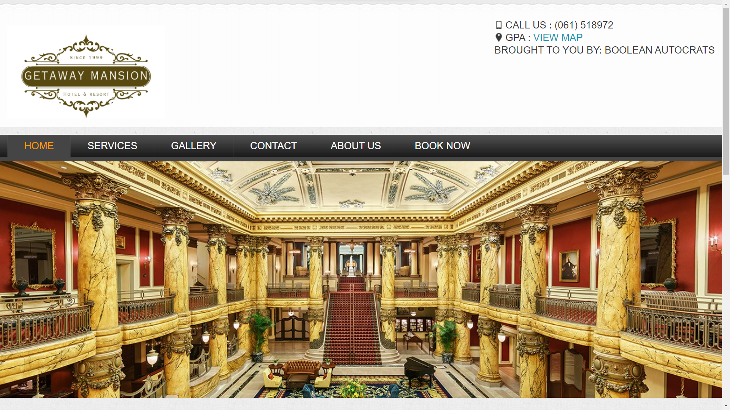

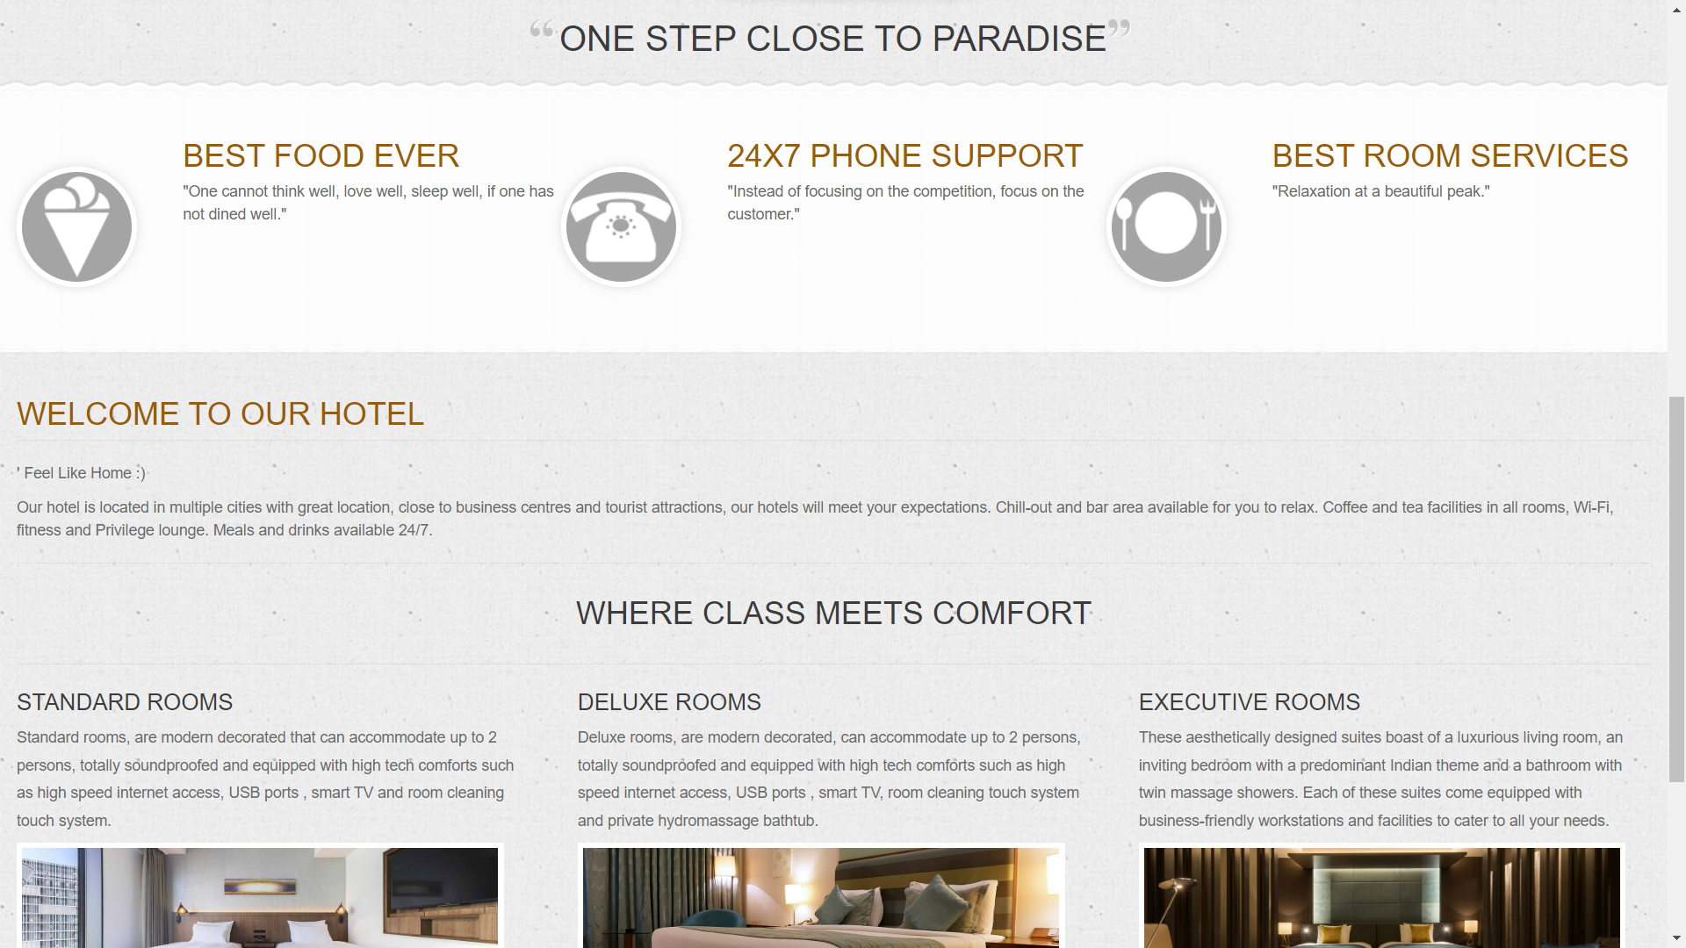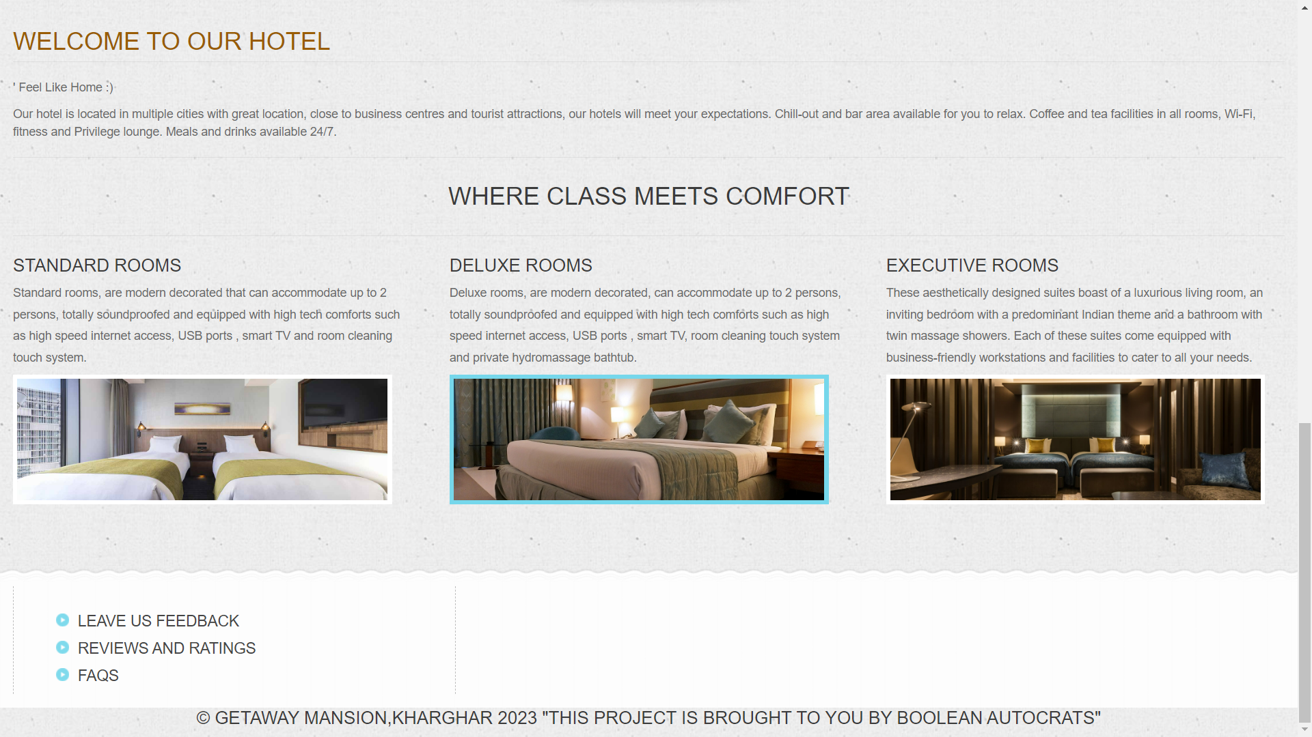

**\**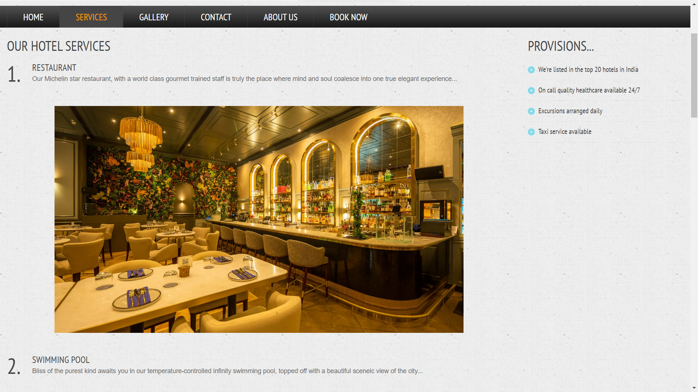

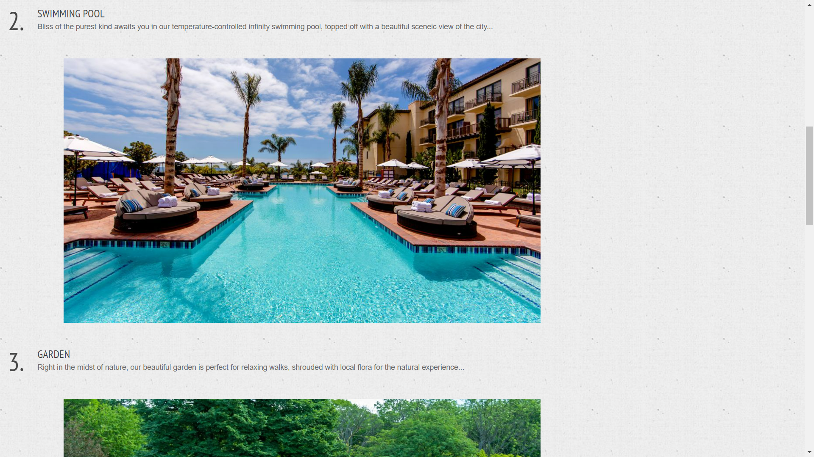

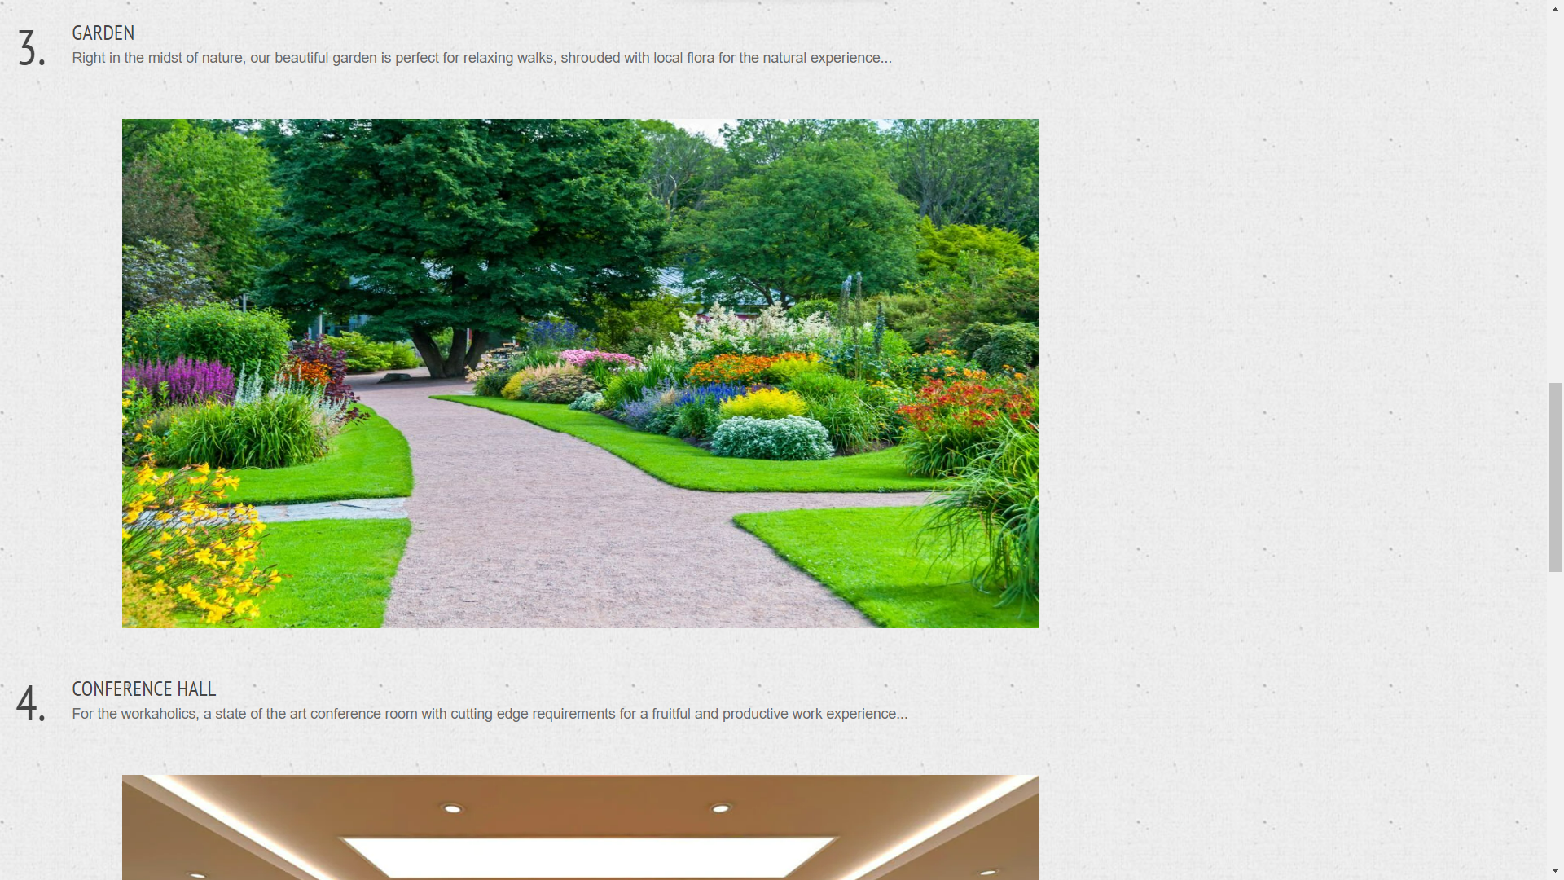

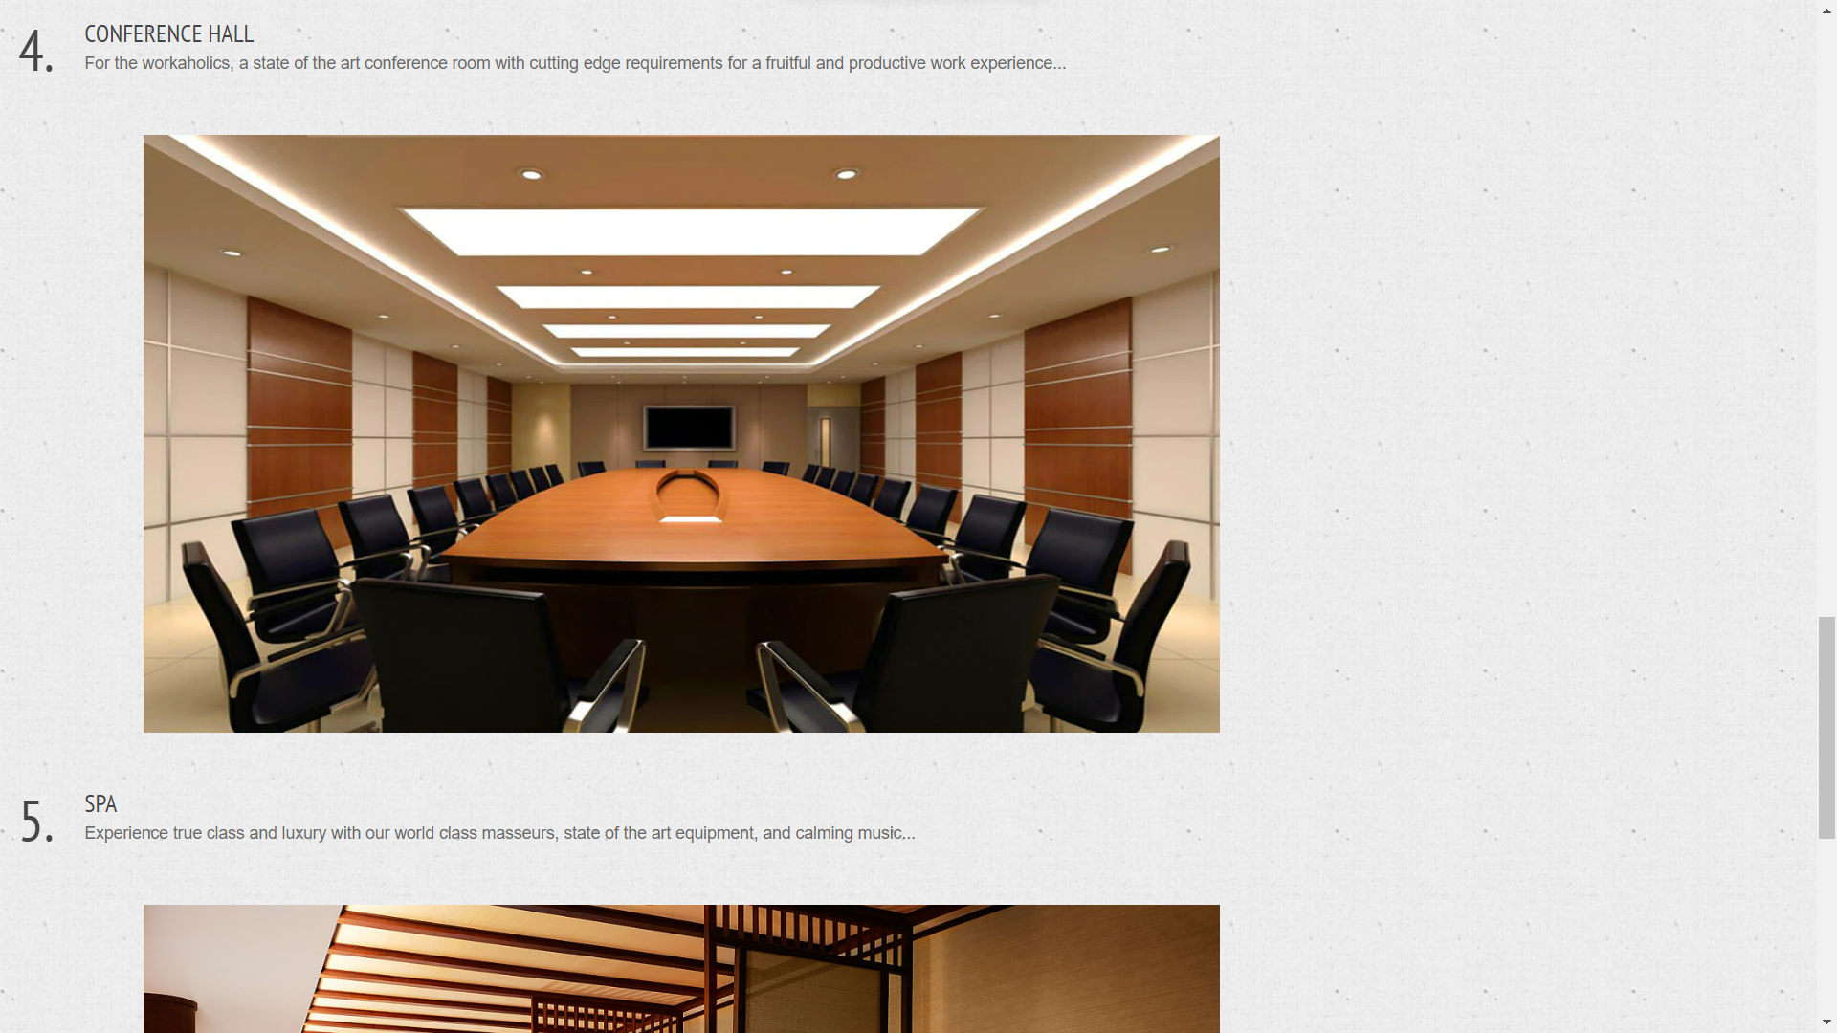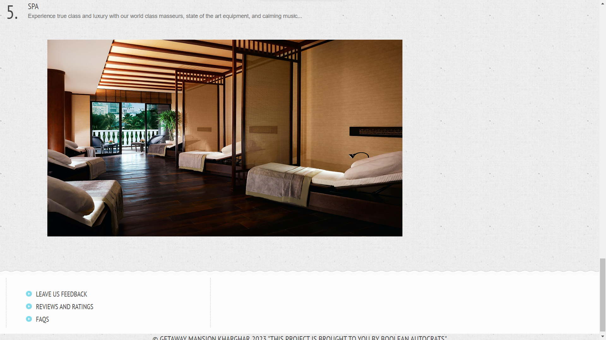

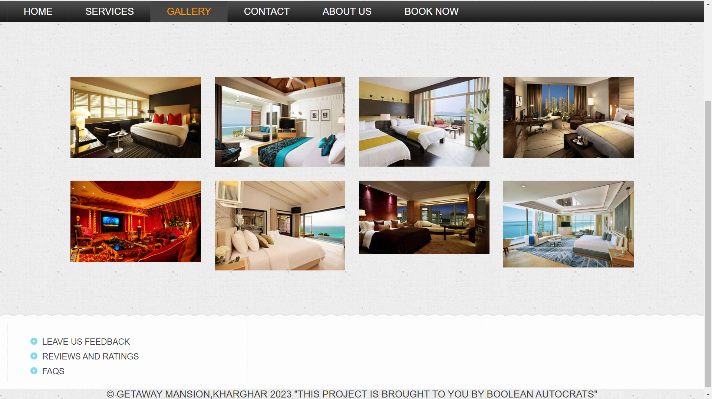

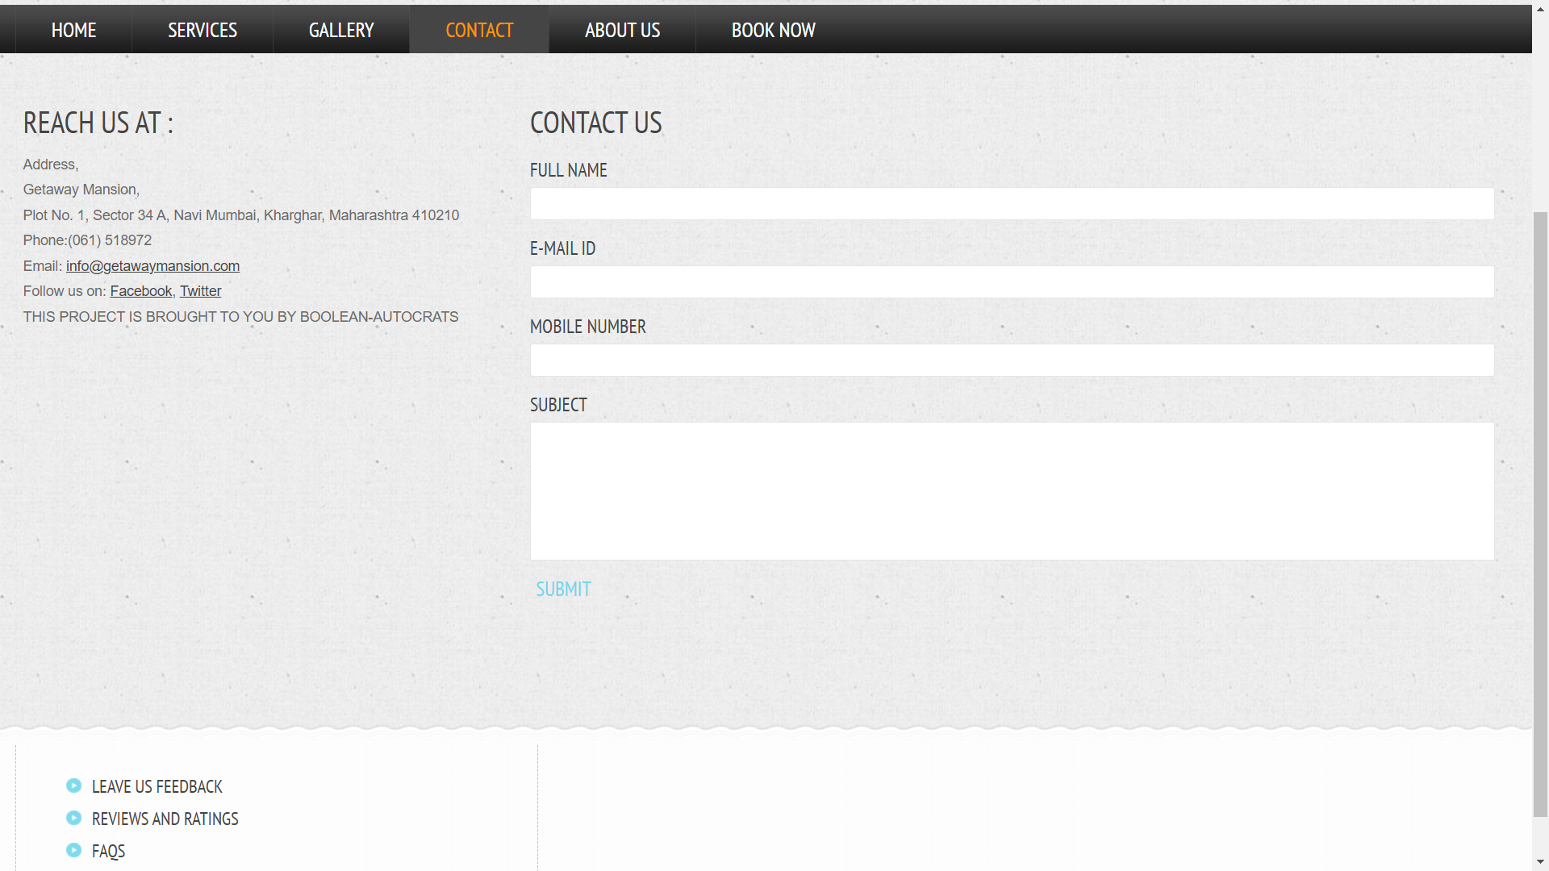

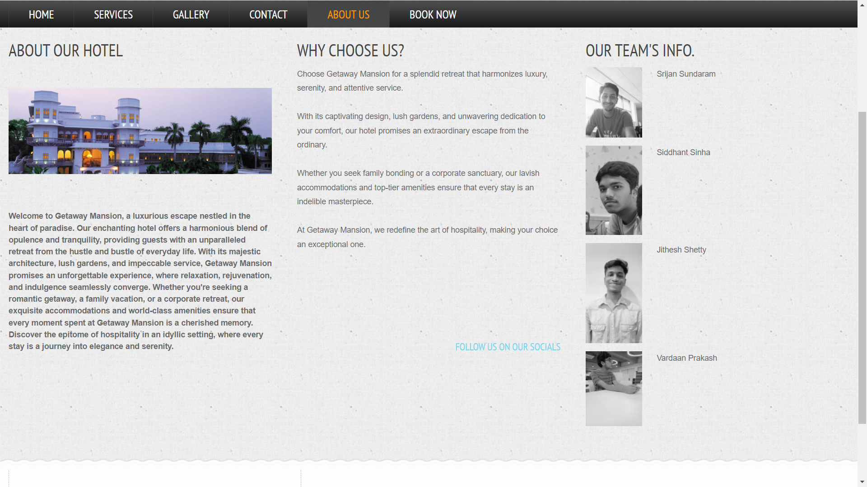

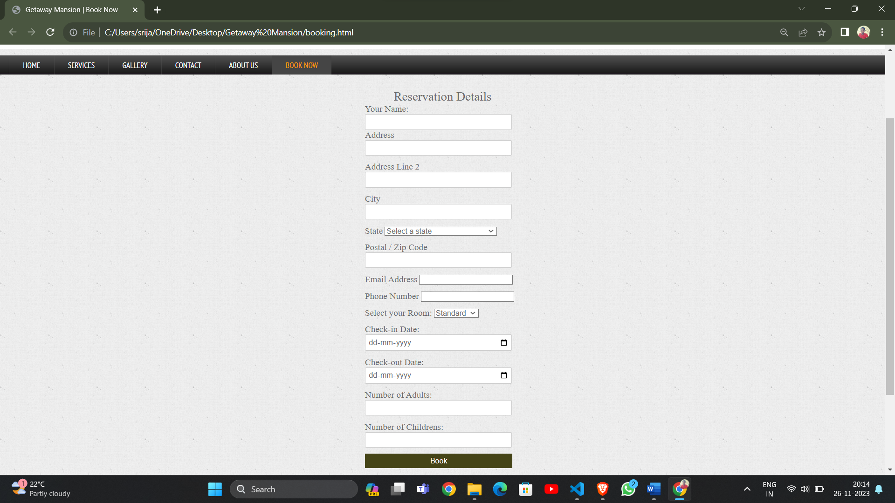

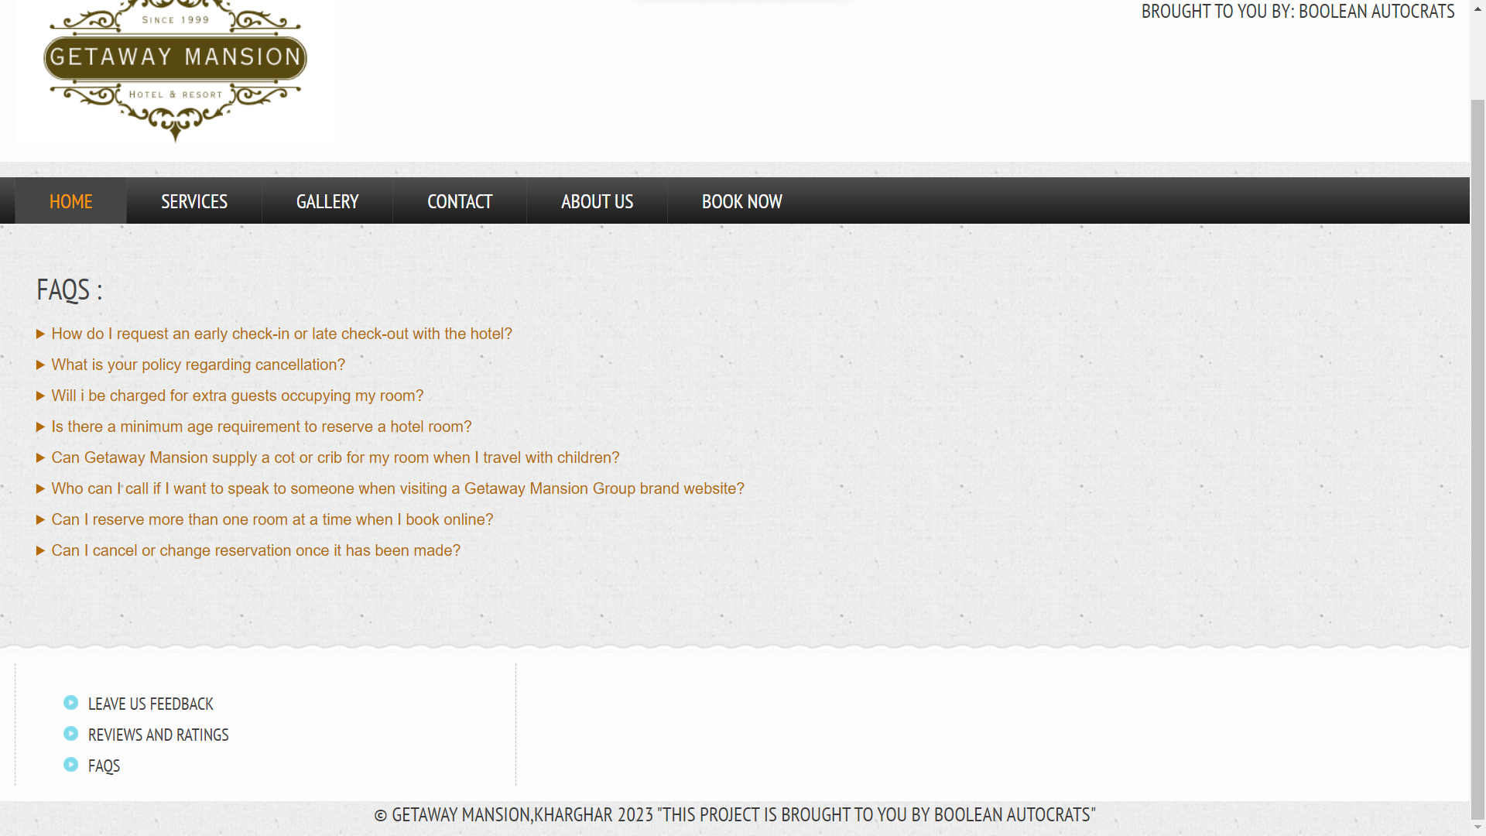

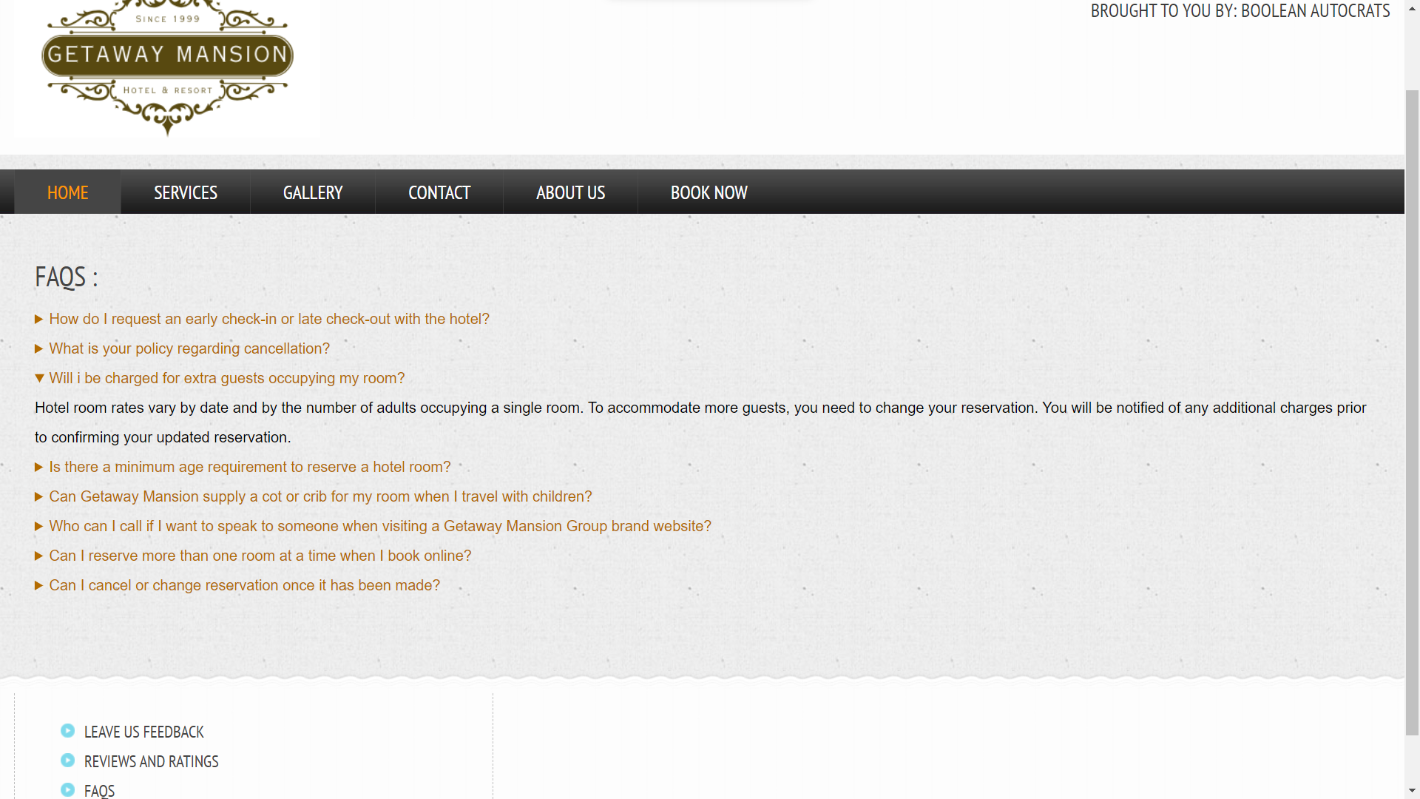

**Conclusion**

Computer has got clear advantage over the manual system. The computerized system is more reliable, efficient and fast at the end of the project, I can say that computer play a very crucial role in the development of firm. All the daily reports generated by the system are to be checked by the concerned official so as to ensure that all the transactions have been put through in appropriate accounts and this is tallied with the new vouchers.

Computer does maximum work with in minimum time. Because it is used in every field so that it provides comfort and suitability to everyone. Providing maximum facilities and comfort to customers to customers is main goal of the firm. To achieve this goal, other modern facilities relating to computer should have to be provided.

# References

1. HTML & CSS: The Complete Reference, Fifth Edition Paperback by Thomas Powell,

McGraw Hill Education

1. W3 Schools. Introduction to HTML and CSS & Responsive Slides
2. Taj Hotels. <https://www.tajhotels.com/>
3. Radisson Hotels. <https://www.radissonhotels.com>